All colloids:
A. are suspension of one phase in another
B. are two-phase system
C. contain only water-soluble particles
D. are true solutions
ANSWER: B
It is an example of lyophilic colloids.
A. Proteins
B. Gum
C. Gelatins
D. All of these
ANSWER: D
It is not an example of lyophobic colloids.
A. Sulphur
B. Gold
C. Iron
D. None of these
ANSWER: D
Which property of colloids is not dependent on the charge on colloidal particles?
A. Coagulation
B. Electrophoresis
C. Electro-osmosis
D. Tyndall effect
ANSWER: D
Which of the following statement are false regarding the colloidal solution?

P. Colloidal solutions are homogeneous in nature.

Q. Colloidal particles pass through an ordinary filter paper.

R. Colloidal particles can be seen with naked eyes.

S. Colloidal particles do not settle under gravity.
A. P and R
B. P and S
C. Q and R
D. R and S
ANSWER: A
Which of the following statement is not true about the colloidal solution?
A. These are visible under powerful microscope
B. Their particles do not settle down with passage of time
C. Their particles are electrically charged
D. These are homogeneous in nature
ANSWER: D
What happens when light is passed through a colloidal solution?
A. Path of light through the colloid becomes invisible.
B. Path of light through the colloid becomes visible.
C. There's no effect.
D. There's no scattering of light.
ANSWER: B
A liquid is found to scatter a beam of light but leaves no residue when passed through the filter paper. The liquid can be described as:
A. a suspension
B. oil
C. a colloidal sol
D. a true solution
ANSWER: C
Which of the following is an example of emulsion?
A. Milk of magnesia
B. Halwa
C. Smoke
D. Milk
ANSWER: D
Soap leather is an example of
A. Foam
B. Emulsion
C. Aerosol
D. Gel
ANSWER: A
It is not correct for the properties of colloids.
A. Colloids are cloudy
B. Colloids exhibit Brownian motion
C. Colloids particles have the power of diffusion
D. Colloidal particles do not settle under the influence of gravity
ANSWER: C
Which phenomenon is observed in the picture with the help of Sun?

A. Brownian motion
B. Colloidal solution
C. Tyndall effect
D. All of these
ANSWER: C
It is an example of which type of colloidal solution.
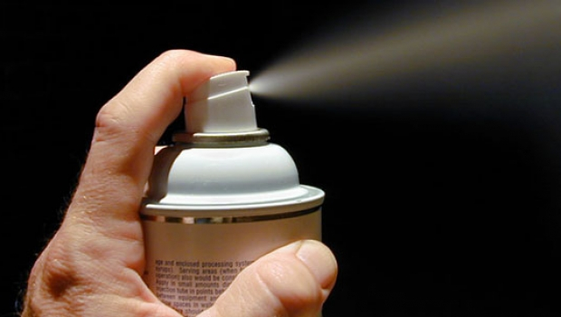
A. Foam
B. Emulsion
C. Aerosol
D. Gel
ANSWER: C
One of following substances that belongs to colloid system is.
A. Milk
B. water
C. Vinegar
D. Blood
ANSWER: A

Dispersed phase and dispersing medium of smoke are.
A. Solid in liquid
B. Liquid in solid
C. Solid in gas
D. Gas in solid
ANSWER: C

